Aryan Sharma 8025320024 PCS223 — Advanced Computer Networks Lab
Assignment 8
Border Gateway Protocol (BGP)
Configuration and Analysis of BGP Routing
Objective
• To understand the working of Border Gateway Protocol (BGP)
• To configure External BGP (eBGP) between different Autonomous Systems
• To analyze path selection using BGP attributes
Output
Screenshot 1: Topology — All Links Green
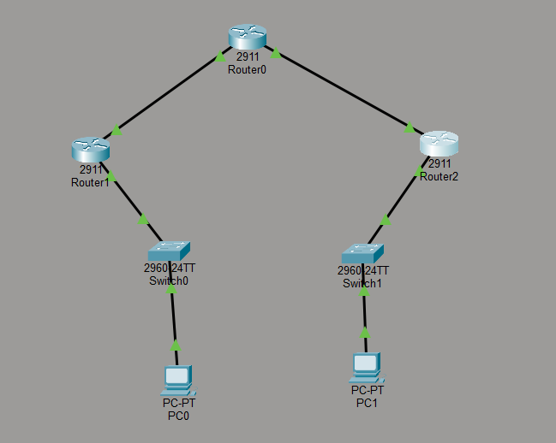________________________________________________________________________

Screenshot 4: show ip bgp summary — Router0 (R2)
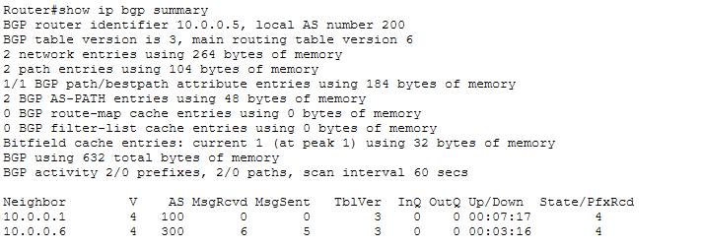________________________________________________________________________
Screenshot 6: show ip bgp — BGP Routing Table
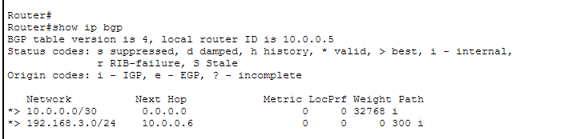________________________________________________________________________
Screenshot 7: show ip route — B Routes
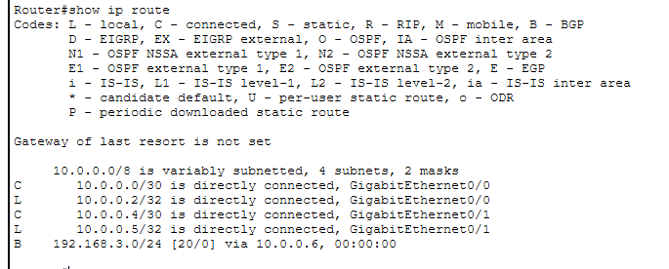________________________________________________________________________

Screenshot 8: Ping PC0 → PC1


